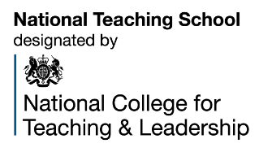

BOOKING FORM

School:
Course Details:
Course Title:

Course Date(s):

Course Fee:

Participant Details:
Name: | Contact Tel No. | Email Address:
Special Requirements (dietary/mobility etc):

Contact Details for invoicing purposes:
Name:  (invoices will be sent separately) | Contact Tel No. | Email Address:

- Places will be allocated on a first come/first served basis
- Confirmation of allocation will be sent via email on receipt
- Further details will be sent prior to the start of the programme
- If for any reason you need to cancel your booking unfortunately a refund will only be issued if we are able to fill your place
- Where a course that is free of charge is cancelled at short notice (less than 48 hours), a cancellation charge of £25 (half day or twilight) or £50 (full day) will be charged.
Contact details:
For further information please contact:
Ann Wilks Director Professional Learning Network
E: directorPLN@lyonshall.org.uk
T: 07917 734531

To make a booking please complete the booking form and return it to: adminPLN@lyonshall.org.uk

